**ST10359128**

**EZEKIEL ISAAC NARAYANASAMI**

**WEDE5020**

**POE**

**PART 1**

**1**

**TABLE OF CONTENTS**

**Contents Page**

Cover Page 1

Table of Contents 2

Website Choice 3

Website Assets 4

Website Pages and Content 5

Reference List 6

**2**

**Website Choice**

My idea for my POE is a Children’s Orphanage called **Red House, FSADY** (For South Africa’s Disadvantaged Youth)**,** it will be a non-profitable organization that will only be in concern for helping the children that have been abandoned or at a life disadvantage. It will accept donations such as old or new clothing for the children, new or used electronic devices to be put towards helping the children advance through our modern developing world, and money that will be put towards education such as uniforms and stationery as we encourage them and give them the chance to succeed in the education industry. Fundraisers such as plays, concerts and musicals will be in place to raise money and help the developing children to get their minds off their pasts and focus on their goals and what they can achieve in their future. This non profitable organization is a chance for us to change their lives as statistics show that 6 out of 10 children in South Africa live in poverty and that is more than 60 percent of South Africa’s children population, from 2014 up to today’s date it shows that over 250 000 children are homeless and live on the streets of South Africa, and between the months of October and December of 2021 more than 300 children were killed, close to 400 survived attempted murder and more than 2000 were victims of physical abuse. So, this organization is created for the children allowing them to benefit from it by giving them opportunities to succeed in their futures, enough food to keep them satisfied, putting them under a roof and keeping them out of harm’s way and in a safe controlled environment where they will learn, associate with other children around their ages, and be treated the right way. Another example of this organization that I want to create is a running organization called The Durban Child and Youth Care Centre where they focus on improving the lives of the children of South Africa by keeping them safe, giving them an education and letting them experience life as a child the right way. Every child deserves a decent stable future, and we have the power to make those changes to their lives.

**3**

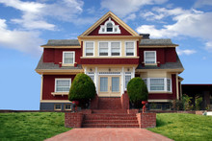

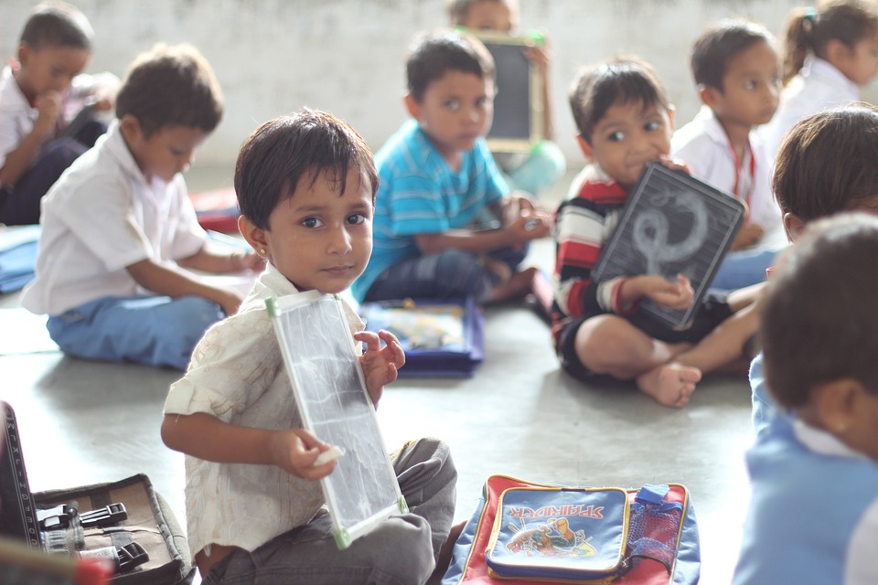

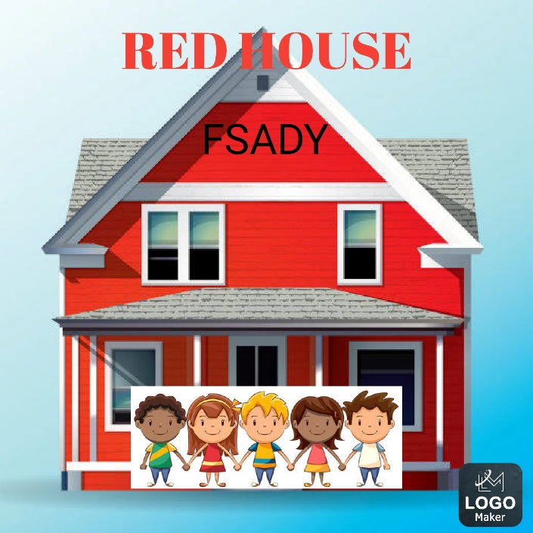

**4**

**Website Pages and Content:**

Home Page:

Logo

Slogan

Links to Other Pages

Photo of Organization and Children

About Us Page:

Summary of Aim and a Description

Contact Us Page:

Image of contact information example.

Phone Number

Inbox

Email Address

News Page:

News page image

New and Upcoming Events

Donate Page:

What donations are Used for.

Donation image

Address to send Donations to

Bank Account Information

**5**

**Reference List:**

Essay:

Durban Child and Youth Care Centre: https://dch.org.za

UNICEF: https://www.unicef.org

Images:

Red houses images: adapted from google.

Children a part of orphanages: adapted from reddit: https://www.redditinc.com.

Other images adapted from https://www.redditinc.com.

Logo Maker App from Play Store

Website Pages and Content:

Examples from the POE and WEDE5020 Notes.

**6**